Student **DATABASE**

Huy Bui **Fundamentals of SQL Server Management Studio**

Information Technology ***Creating Database Objects***

T5616SN 21 January 2018

Timo Mynttinen

**THEORY PART: TYPICAL DATA TYPES IN SQL SERVER**

**Introduction**

In SQL Server, each column, local variable, expression, and parameter has a related data type. A data type is an attribute that specifies the type of data that the object can hold. Data types in SQL Server are organized into the following categories:

Exact numerics Unicode character strings

Approximate numerics Binary strings

Date and time Other data types

Character strings

In SQL Server, based on their storage characteristics, some data types are designated as belonging to the following groups:

* Large value data types: varchar(max), nvarchar(max), and varbinary(max)
* Large object data types: text, ntext, image, varchar(max), nvarchar(max), varbinary(max), and xml

**Typical data types**

The table below shows the most general data types in SQL:

|  |  |
| --- | --- |
| **Data type** | **Description** |
| CHARACTER(n) | Character string. Fixed-length n |
| VARCHAR(n) or CHARACTER VARYING(n) | Character string. Variable length. Maximum length n |
| BINARY(n) | Binary string. Fixed-length n |
| BOOLEAN | Stores TRUE or FALSE values |
| VARBINARY(n) or BINARY VARYING(n) | Binary string. Variable length. Maximum length n |
| INTEGER(p) | Integer numerical (no decimal). Precision p |
| SMALLINT | Integer numerical (no decimal). Precision 5 |
| INTEGER | Integer numerical (no decimal). Precision 10 |
| BIGINT | Integer numerical (no decimal). Precision 19 |
| DECIMAL(p,s) | Exact numerical, precision p, scale s. Example: decimal(5,2) is a number that has 3 digits before the decimal and 2 digits after the decimal |
| NUMERIC(p,s) | Exact numerical, precision p, scale s. (Same as DECIMAL) |
| FLOAT(p) | Approximate numerical, mantissa precision p. A floating number in base 10 exponential notation. The size argument for this type consists of a single number specifying the minimum precision |
| REAL | Approximate numerical, mantissa precision 7 |
| FLOAT | Approximate numerical, mantissa precision 16 |
| DOUBLE PRECISION | Approximate numerical, mantissa precision 16 |
| DATE | Stores year, month, and day values |
| TIME | Stores hour, minute, and second values |
| TIMESTAMP | Stores year, month, day, hour, minute, and second values |
| INTERVAL | Composed of a number of integer fields, representing a period of time, depending on the type of interval |
| ARRAY | A set-length and ordered collection of elements |
| MULTISET | A variable-length and unordered collection of elements |
| XML | Stores XML data |

**PRACTICAL PART**

**Creating database and table**

To create new database, in **Object Explorer** box, right click **Database** and select New Database.

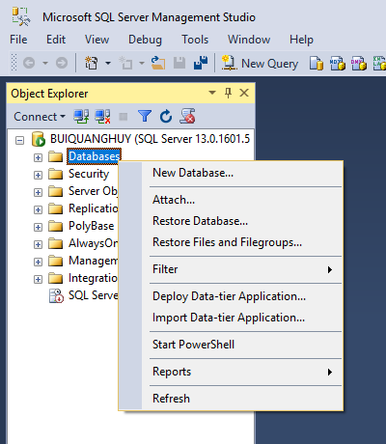

Type database’s name and click **Ok**.

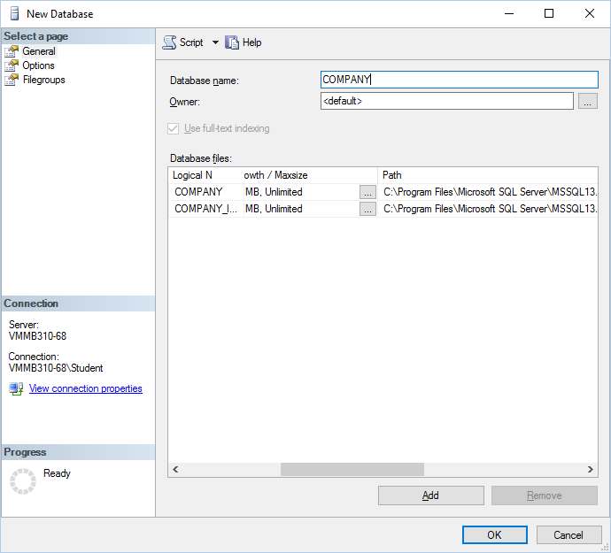

You may have to click refresh button, which is on the top of **Object Explorer** box, so that your new database can be displayed.

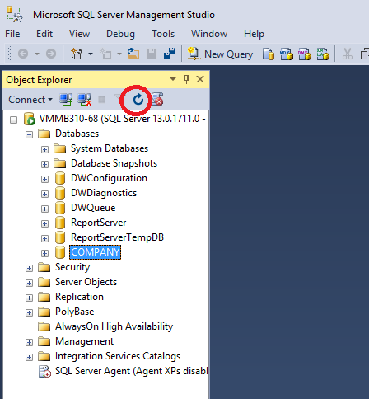

To create table, expand **COMPANY** database and right click **Table** folder, then choose **New Table**.

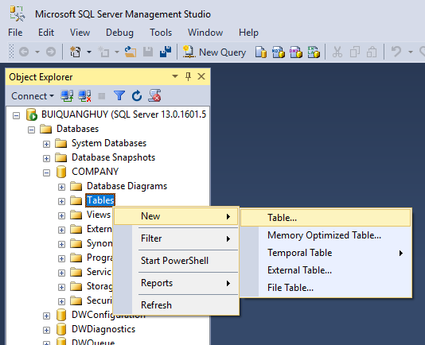

Add columns to the new table and remember to set primary key so that each row in the table is always unique. Additionally, the ID can be set automatically by enabling identity specification.

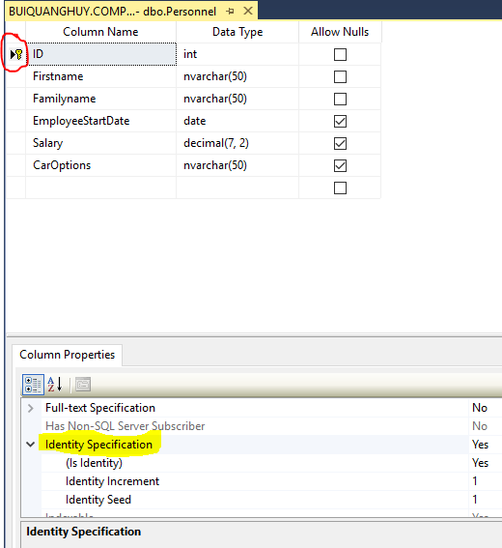

**Add DEFAULT date value**

To add default value to column **EmployeeStartDate** when it is nulls, in the **Column Properties,** type **getdate()** in **Default value or Binding.**

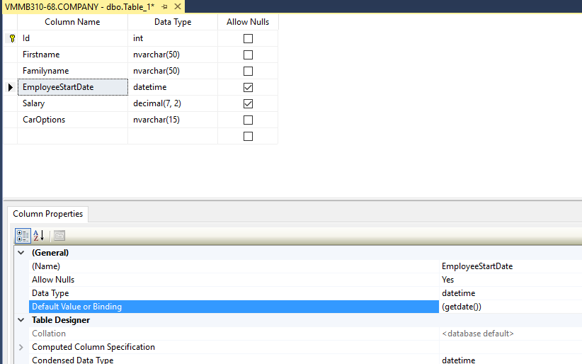

**Adding CHECK CONSTRAINT to column**

* *What is CHECK CONSTRAINT?*  
  The CHECK constraint is used to limit the value range that can be placed in a column. If you define a CHECK constraint on a single column it allows only certain values for this column. If you define a CHECK constraint on a table it can limit the values in certain columns based on values in other columns in the row.
* *To create a new CHECK CONSTRAINT*In **Object Explorer**, expand the table to which you want to add a check constraint, right-click **Constraints** and click **New Constraint**.  
  In the **Check Constraints** dialog box, click in the **Expression field** and then click the ellipses (…).  
  In the **Check Constraint Expression** dialog box, type the SQL expressions for the check constraint. For example, add **Check Constraint** to the column **EmployeeStartDate** so that the the datecan’t be earlier than you want it to be, type:  
  ([EmployeeStartDate]>CONVERT([date],'2005-12-31'))  
    
  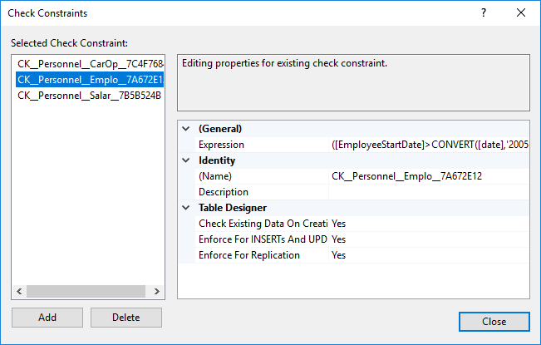  
    
  Similarly, we can add Check constraint to the column Salary so that each Employee must have a minimum salary.  
  ([Salary]>(100))  
  Add Check constraint to the column CarOptions. The possible options are SunRoof, Spoiler, FogLights, and TintedWindows.  
  ([CarOptions]='TintedWindows' OR [CarOptions]='FogLights' OR [CarOptions]='Spoiler' OR [CarOptions]='SunRoof')

**Creating Table script file**

* To create the script CreatePersonnel.sql by which we can create table Personnel again into a new database, do the following steps:
  + Expand **Databases**, and then expand the Tables node.
  + Right-click the object (**dbo.Personnel**), point to **Script Table as**.
  + Point to the script type (**Create to**) and select file.
  + Select the location to save the script file.  
    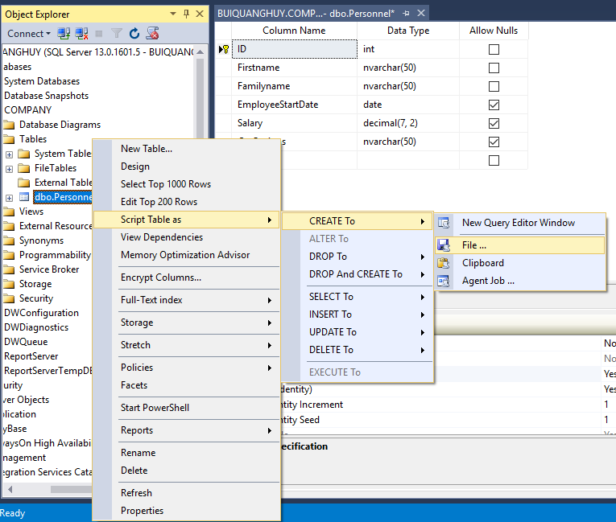
* Similarly, we can create script file InsertIntoPersonnel.sql which is used to add all the rows into table Personnel. The only difference is the script type, which should be INSERT To:  
  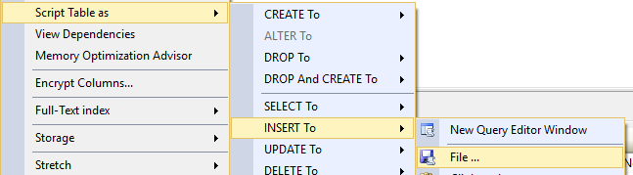

**Testing the work**

The source code of the CreatePersonnel.sql script file is shown as below:



To test the work, I added data as required using InsertPersonnel.Sql script file:



After press execute, I had:

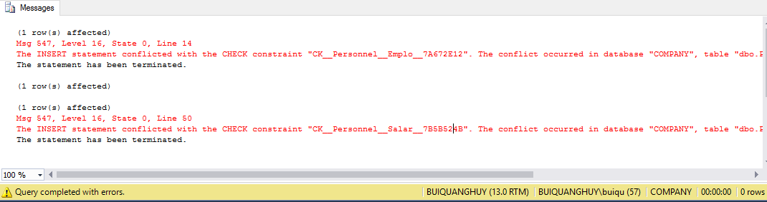



Using SELECT statement, the final result is shown as below:

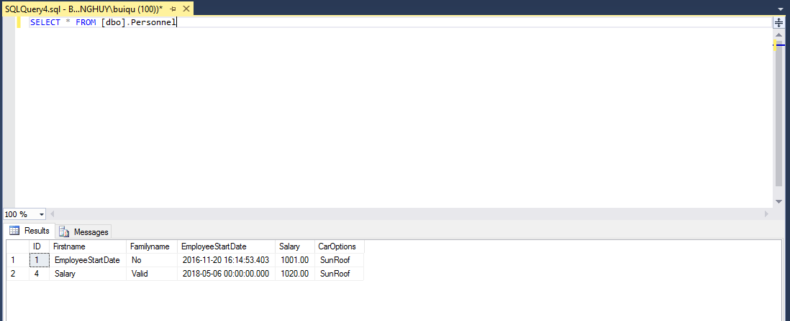

To make it ease, I include all codes from CreatePersonnel.sql and InsertPersonnel.sql into one script file, so that I can create Personnel table and insert rows into it at the same time, with just one file. To avoid errors, I just keep valid rows and remove the invalid ones:

USE [IADTask1]

GO

/****** Object: Table [dbo].[Personnel] Script Date: 20/11/2016 4:05:40 PM ******/

SET ANSI_NULLS ON

GO

SET QUOTED_IDENTIFIER ON

GO

CREATE TABLE [dbo].[Personnel](

[ID] [int] IDENTITY(1,1) NOT NULL,

[Firstname] [nvarchar](50) NOT NULL,

[Familyname] [nvarchar](50) NOT NULL,

[EmployeeStartDate] [datetime] NULL,

[Salary] [decimal](7, 2) NULL,

[CarOptions] [nvarchar](15) NOT NULL,

CONSTRAINT [PK_Personnel] PRIMARY KEY CLUSTERED

(

[ID] ASC

)WITH (PAD_INDEX = OFF, STATISTICS_NORECOMPUTE = OFF, IGNORE_DUP_KEY = OFF, ALLOW_ROW_LOCKS = ON, ALLOW_PAGE_LOCKS = ON) ON [PRIMARY]

) ON [PRIMARY]

GO

ALTER TABLE [dbo].[Personnel] ADD CONSTRAINT [DF_Personnel_EmployeeStartDate] DEFAULT (getdate()) FOR [EmployeeStartDate]

GO

ALTER TABLE [dbo].[Personnel] WITH CHECK ADD CONSTRAINT [CK_Personnel_CarOptions] CHECK (([CarOptions]='TintedWindows' OR [CarOptions]='FogLights' OR [CarOptions]='Spoiler' OR [CarOptions]='SunRoof'))

GO

ALTER TABLE [dbo].[Personnel] CHECK CONSTRAINT [CK_Personnel_CarOptions]

GO

ALTER TABLE [dbo].[Personnel] WITH CHECK ADD CONSTRAINT [CK_Personnel_EmployeeStartDate] CHECK (([EmployeeStartDate]>=getdate()))

GO

ALTER TABLE [dbo].[Personnel] CHECK CONSTRAINT [CK_Personnel_EmployeeStartDate]

GO

ALTER TABLE [dbo].[Personnel] WITH CHECK ADD CONSTRAINT [CK_Personnel_MinimumSalary] CHECK (([Salary]>(1000)))

GO

ALTER TABLE [dbo].[Personnel] CHECK CONSTRAINT [CK_Personnel_MinimumSalary]

GO

USE [IADTask1]

GO

INSERT INTO [dbo].[Personnel]

([Firstname]

,[Familyname]

,[Salary]

,[CarOptions])

VALUES

('EmployeeStartDate'

,'No'

,1001

,'SunRoof')

GO

INSERT INTO [dbo].[Personnel]

([Firstname]

,[Familyname]

,[EmployeeStartDate]

,[Salary]

,[CarOptions])

VALUES

('EmployeeStartDate'

,'Valid'

,'2018-05-06'

,300

,'TintedWindows')

GO

INSERT INTO [dbo].[Personnel]

([Firstname]

,[Familyname]

,[EmployeeStartDate]

,[Salary]

,[CarOptions])

VALUES

('Salary'

,'Valid'

,'2018-05-06'

,1020

,'Spoiler')

GO

SELECT * FROM [dbo].Personnel